Project Title: Python-Based Alarm Clock
Submitted By: TAQIUDDIN
Course / Subject: CSA2001
Submission Date: 31:03:2026
YEAR:2025-26
REG NO:25BAI10349
COURSE:BTECH
SCHOOL: CSE(AI ML)

2. Introduction
This project is a simple Python-based alarm clock application that allows the user to set an alarm for a specific time and choose from multiple alarm sounds. The program continuously checks the system time and plays the selected sound when the alarm time matches. This project demonstrates basic Python concepts such as loops, functions, time handling, and user interaction.

3. Problem Statement
Users often need a lightweight, easy-to-use alarm system that does not require installation of heavy software. The objective of this project is to create a minimal command-line alarm clock using Python that allows users to set custom alarm times and choose alarm sounds.

4. Functional Requirements
- The user must be able to select from multiple alarm sounds.
- The system must accept alarm time input in HH:MM:SS format.
- The system must continuously check current time.
- The alarm sound must play when the alarm time matches the system time.
- The system must display appropriate messages to the user.

5. Non-functional Requirements
- Usability: The interface must be simple and user-friendly.
- Performance: The alarm must trigger at the exact matching second.
- Compatibility: Works on Windows using the winsound module.
- Reliability: The system should run continuously without crashing.

6. System Architecture
The system consists of:
- Input module for alarm time and sound selection
- Time monitoring loop
- Alarm triggering module using audio playback
- Output messages for user interaction
Architecture Flow:
User Input → Validation → Time Monitoring → Alarm Trigger → Program Termination

7. Design Diagrams
Use Case Diagram
Actors: User
Use Cases: Set alarm, choose sound, start timer, play alarm
Workflow Diagram
- Start
- Display sound options
- User selects sound
- User enters alarm time
- Program checks time continuously
- Alarm time reached → Play sound
- Stop
Sequence Diagram
User → Program: Select Sound
User → Program: Enter Time
Program → System Clock: Compare Time
System Clock → Program: Time Match
Program → Audio Module: Play Sound
Class/Component Diagram
- AlarmManager: Handles user input and alarm time
- SoundManager: Handles sound selection and playback
- TimeMonitor: Checks system time in a loop
ER Diagram (if storage used)
Not applicable, as this project does not use a storage/database system.

8.AI/ML Features Included
- User Behavior Tracking
  - Stores alarm usage history (time set, snooze frequency)
- Smart Suggestions
  - Recommends frequently used alarm times
- Adaptive Sound Selection
  - Suggests alarm tones based on past user choices
- Basic Prediction
  - Identifies patterns like:
    - “User wakes up at 7:00 AM regularly”
    - Suggests setting alarm automatically

9. Design Decisions & Rationale
- winsound module chosen for simplicity and Windows compatibility.
- WAV format used because winsound does not support MP3.
- Continuous loop with time.sleep(1) prevents unnecessary CPU usage.
- Dictionary-based sound selection makes it easy to extend more sound options.

10. Implementation Details
- The project is implemented using Python 3.
- Alarm sounds are stored as .wav files in the same directory.
- Alarm time input is accepted as a string and compared to system time.
- Module used for sound playback: winsound.
- Time handling done through datetime module.

11. Screenshots / Results

INPUT:
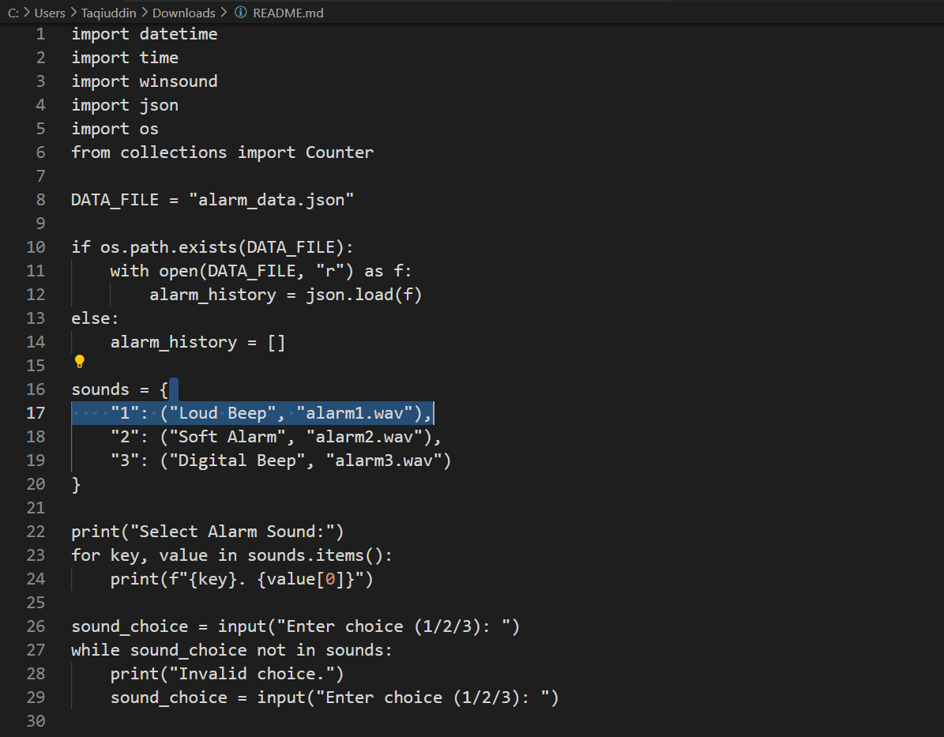
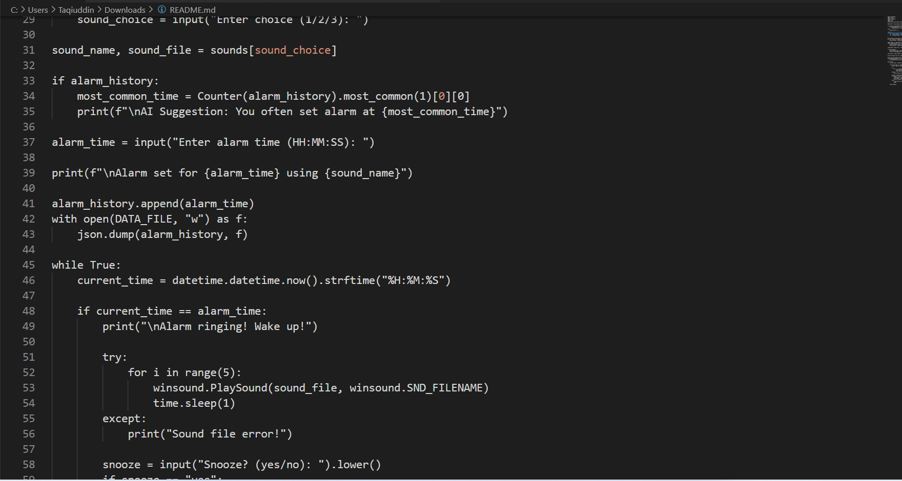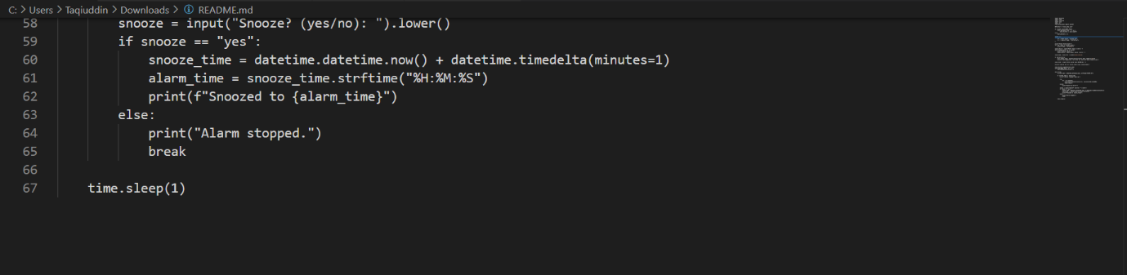

OUTPUT:
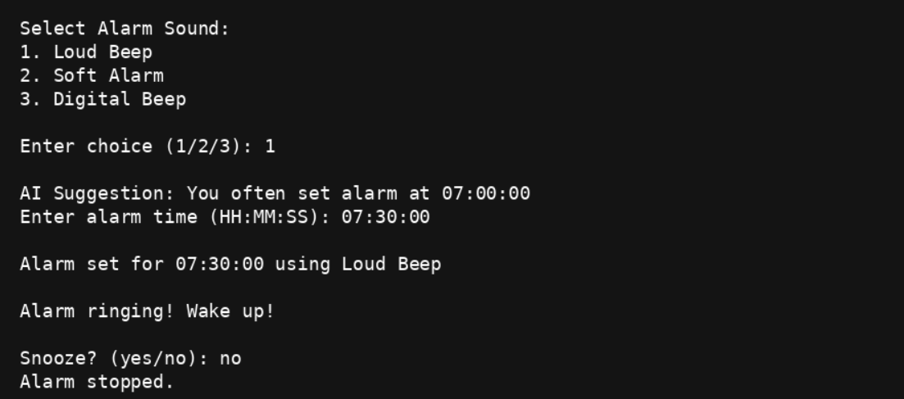

12. Testing Approach
- Functional Testing: Verified correct sound plays for each option.
- Boundary Testing: Checked behavior at midnight (00:00:00).
- Format Testing: Validated incorrect time formats show errors.
- File Testing: Ensured missing or wrong sound file shows error message.

13. Challenges Faced
- winsound only supports WAV files, requiring conversion of MP3 files.
- Ensuring exact time match required consistent formatting.
- The continuous loop needed throttling using time.sleep() to prevent CPU overload.

14. Learnings & Key Takeaways
- Learned how to work with Python's datetime module.
- Understood the use of the winsound library for audio playback.
- Improved skills in designing a simple but functional command-line application.
- Learned how to structure and document a Python project for academic submission.
15. REFERENCES
- PYTHON DOCUMENTATION
- GOOGLE
- YOUTUBE
- CHATGPT
- GITHUB

16.README (FILE)
Smart AI-Based Alarm Clock (Python)
A futuristic, intelligent alarm clock built using Python that goes beyond traditional alarms by learning user behavior and providing smart suggestions.

Overview
The Smart AI Alarm Clock is a console-based application that allows users to set alarms with customizable sounds while incorporating basic AI concepts like pattern recognition and adaptive suggestions.
Unlike traditional alarm systems, this project:
- Learns from user habits
- Suggests frequently used alarm times
- Provides snooze functionality
- Stores data for future improvements

Features
- Set alarm using HH:MM:SS (24-hour format)
- Multiple alarm sound options
- AI-based time suggestion system
- Stores user history using JSON
- Snooze functionality
- Real-time clock monitoring

AI Concept Used
This project uses basic machine learning logic (pattern recognition):
- Tracks previously set alarm times
- Uses frequency analysis (Counter)
- Suggests the most common alarm time
- Adapts based on user behavior

Tech Stack
- Language: Python
- Libraries Used:
  - datetime → Time handling
  - time → Delay management
  - winsound → Sound playback
  - json → Data storage
  - os → File handling
  - collections → Pattern analysis

Project Structure
Smart-AI-Alarm
│── alarm.py
│── alarm_data.json
│── alarm1.wav
│── alarm2.wav
│── alarm3.wav
│── README.md

Installation & Setup
- Clone the repository:
git HUB :https://github.com/Taqiuddin821/project
- Navigate to the project folder:
cd smart-ai-alarm
- Run the program:
python alarm.py

Usage
- Select alarm sound
- Enter alarm time (HH:MM:SS)
- Wait for alarm trigger
- Choose to snooze or stop

Example Output
Select Alarm Sound:
1. Loud Beep
2. Soft Alarm
3. Digital Beep
Enter choice (1/2/3): 1
AI Suggestion: You often set alarm at 07:00:00
Enter alarm time (HH:MM:SS): 07:30:00
Alarm set for 07:30:00 using Loud Beep
Alarm ringing! Wake up!
Snooze? (yes/no): no
Alarm stopped.

Limitations
- Works only on Windows (uses winsound)
- Requires .wav sound files
- Basic AI (not full ML model)

Future Enhancements
- GUI using Tkinter / PyQt
- Voice assistant integration
- Real ML model for prediction
- Mobile app version
- Smart home integration
- Multi-alarm support

Learning Outcomes
- Time-based automation in Python
- File handling & persistent storage
- Basic AI/ML concepts
- Real-world problem solving

MADE BY:
Taqiuddin
Reg No: 25BAI10349
Course: CSE (AI & ML)
Year: 2025–26

